Title (Times New Roman Bold 16pt)

A. Author1^{1*}, B. Author2^{,2} and C. Author3¹ (Times New Roman 12 pt)

¹First Institution, Address, Country (Times New Roman Italic 10 pt)
²Second Institution, Address, Country
*Corresponding author: author1@email.com

Here starts the abstract of the maximum length of one page. Please use Times New Roman 12 pt and single line spacing. The authors should be indicated by the last name and initials of the first name. The presenting author should be underlined. Add one extra line between the paragraphs.

Figures may be included. References should be in brackets like [1].

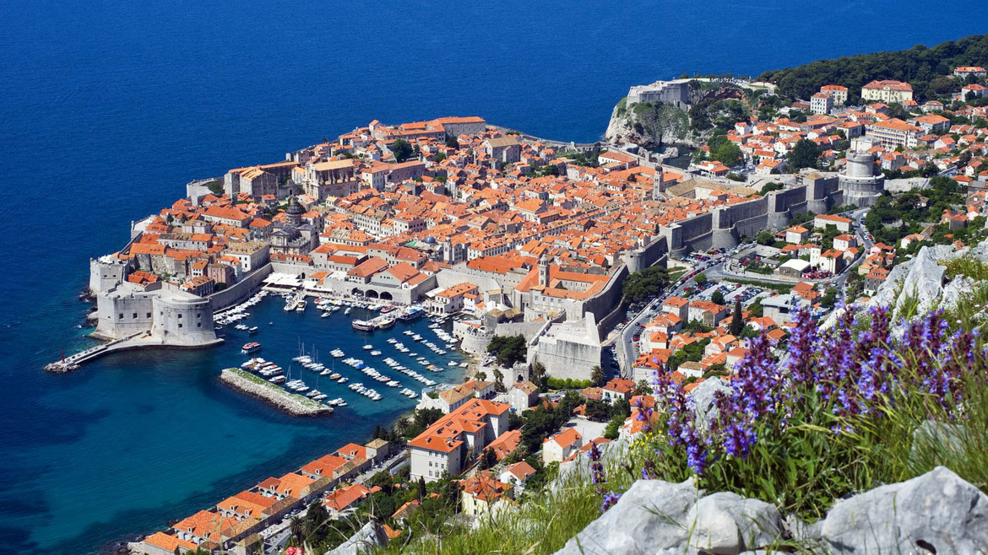

Figure 1: The Old Town of Dubrovnik (Times New Roman 10 pt)

Acknowledgments: (Times New Roman 12 pt)

References
[1] A. Author1, B. Author2 and C. Author3, Journal Year, Volume, 1stPage-lastPage.

